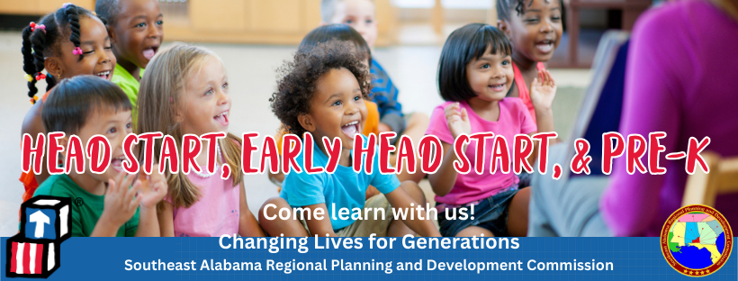

Annual Report
FY2022-2023
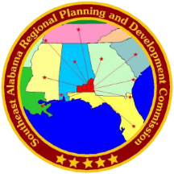
This annual report contains Southeast Alabama Regional Planning and Development Commission (SEARP&DC) and Head Start/Early Head Start Program information for the school year 2022-2023. The SEARP&DC Head Start school year follows each service area public school calendar, which began in August 2022 and ended in May 2023. The Early Head Start Calendar began in August 2021 and ended in July 2022. Early Head Start operates year-round; therefore, this report covers a 12-month period.
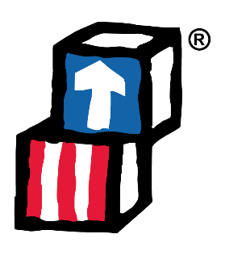
Our Head Start Program provides services to children and families in Barbour, Covington, Geneva, and Henry Counties. The SEARP&DC Head Start Program is funded to enroll 284 Head Start children (ages 3-5) and 32 Early Head Start children (0-3). During the pandemic our enrollment fell to about 80%. The Office of Head Start regulations require 90% of children to be enrolled from families that are at or below the poverty guideline. In addition, it requires that children eligible for services under IDEA must fill at least 10% of its total funded enrollment. SEARP&DC Head Start Program usually maintains a full enrollment of 316 children, but this year, our Headland center had to close right after school started due to environmental issues in the building. At the beginning of the 2023-2024 school year, we are at 81% enrollment while we get classrooms ready in Opp and Geneva to house the two Head Start classrooms that were in the Headland Center, and our Florala center will absorb the two Early Head Start classrooms previously housed in Headland. The city of Florala has no daycares in the area, so as soon as we complete retrofitting the classrooms with the plumbing needed, we will not have any problems filling those classrooms with children. We are expecting full enrollment as soon as the construction is completed and during the 2022-2023 school year, our Head Start Program had 63 full-time employees and one part-time employee.
Our program partnered with the Office of School Readiness to establish a Pre-k classroom in each of our Head Start centers. This was a total of 5 classrooms; the closing of Headland caused one Pre-K unit to close, and the number of eligible students available for the Pre-K class in Eufaula had dwindled during the 2023-2023 school year and will be converted to a Head Start classroom for the 2023-2024 school year. All other Pre-K classrooms were fully enrolled.
SEARP&DC’s Head Start & Early Head Start Program
Service Area Overview

County/City Where Center Operates | # of Head Start Classrooms | # of Early Head Start Classrooms | Average Student Enrollment  Head Start/Early HS | # of Employees
Barbour/Eufaula | 3 | 0 | 51/0 | 9
Covington/Andalusia | 3 | 2 | 53/16 | 14
Covington/Florala | 2 | 0 | 36/0 | 6
Covington/Opp | 3 | 0 | 54/0 | 8
Geneva/Geneva | 3 | 0 | 53/0 | 8
Henry/Headland | 2 | 2 | 37/16 | 12
Totals | 16 | 4 | 284 | 57

Central Office, housed in Dothan, AL in Houston County had five (6) administrative employees and one (1) LPN working directly in the managing Head Start, Early Head Start, and the Pre-K program. The SEARP&DC’s Head Start Program also shares in the cost of administrative, accounting, and human resources staff with other SEARP&DC programs.
Employee Fringe Benefits:
Employee fringe benefits include Blue Cross medical and dental insurance, Alabama State Employee Retirement Program, group term life insurance, and disability insurance. Teaching staff are encouraged to reach the next degree in their career, and SEARP&DC helps pay for tuition and books for employees who want to further their education.
The majority of our professional teaching staff has earned college degrees in Child Development, Early Childhood Education, or Child Development Associate credentials, and some of our staff have completed their Bachelor of Science or Bachelor of Arts degree with the help of SEARP&DC. One teacher has obtained his Master’s degree.
Administration and staff participate in yearly professional development during Pre-Service before school starts and Inservice during the year. Well-known educational consultants are brought in to enhance the pedagogy of the staff. Certificates are awarded to staff who complete the training, which builds their professional resume and strengthens our teaching skills.
Enrollment by Financial Eligibility for 2022-2023 School Year:
Head Start Enrollment:
Based on a total enrollment of 284 children (including drop and replacement) 98.5% were eligible coming from families below poverty line and public assistance recipient families. 1.5% were from foster families and/or children exceeding the allowed over-income enrollment with family incomes between 100 percent and 130 percent of the federal poverty line.
Early Head Start Enrollment:
Based on total enrollment of 32 children (including drop and replacement) 100% were eligible coming from families below the poverty line and receiving public assistance.
Services Provided for Children & Families for School Year 22-23
Head Start Services to Children and Parents:
SEARP&DC’s Head Start Program provides education, health, nutrition, mental health, disability, and social services to children and families enrolled within our program. Program Service Managers’ expertise and continued monitoring of the services within each Head Start Center assures that each child and family receive the assistance the program provides. Each Center Director provides local management of the individual Head Start Centers; the Center Directors are like the principal of the center since they oversee both facilities, students, and staff. To foster communication with the families, the staff conducts two home visits and two Parent/Teacher conferences yearly.

Education Services:
The SEARP&DC’s Head Start Program utilizes Creative Curriculum to engage children in a comprehensive leaning process for school readiness. Our program also utilizes the Classroom Assessment Scoring System (CLASS) that observes and measures teacher effectiveness and interactions with children.
Observations were conducted in preschool center-based classrooms using the Classroom Assessment Scoring System (CLASS). The CLASS tool looks at three domains and ten dimensions of teacher-child interactions and measures those observed interactions on a seven-point scale. The following results were noted:
Emotional Support: 6.03 Classroom Organization: 5.8 Instructional Support: 2.82
Teaching Strategies Gold is our online and ongoing child assessment tool that is used in the classroom. This comprehensive resource details the 38 objectives for development and learning—helping the teachers better understand what children know and can do, meet children where they are, and intentionally promote development and learning in ways that recognize children as individuals with different strengths, needs, and interests.
Classrooms also utilize the Hatch system where students login on the computer in the classrooms and learn across seven domains of learning with a focus in math, literacy, and social-emotional development
SEARP&DC’s Head Start has established School Readiness Goals and increased our collaborative efforts with public schools, parents, and community partners. Once again, our school readiness efforts have been successful in engaging parents in supporting their children’s growth in language, literacy, mathematics, science, creative arts, physical skills, and social and emotional functioning. We continue to take a holistic approach within our program that includes health, nutrition, and disability services. We also have an ongoing transition program that engages parents in supporting their child’s ongoing learning and development efforts. When our children transition to kindergarten, they are equipped for additional learning and development to the best of their abilities.

Health Services:
We provide medical and dental exams to our children every year. During the 2022-2023 school year, we also provided medical services and dental preventative care services to children. Children receive follow-up treatment on an as needed basis. All children’s physical is monitored by the Family Service Specialist to ensure that any medical concerns or alerts are followed by the parents and the child’s health care provider. The FSS also helps families who are uninsured get health insurance.

Nutrition Services:
The SEARP&DC Head Start Program participates in the USDA Child Nutrition Program to provide a continuum of healthy meals for all children enrolled in our program. Children receive breakfast, lunch and a snack during specified center operating hours. SEARP&DC Head Start receives reimbursements from USDA Child Nutrition Program.

Mental Health Services:
The SEARP&DC Head Start Program contracts with Milestones Psychology and Therapy to provide Mental Health Services to the children and parents within our Head Start Program service area. A mental health professional provides classroom observations and reports findings to Service Managers and Center Directors. We were able to increase our mental health professional service consulting to four times a week. The mental health professional also addresses specific counseling needs as they relate to the parents.

Disability Services:
SEARP&DC’s Head Start Program partners with the local LEA (Local Education Agency) to identify children who may have a learning disability. The teachers and Center Directors work together with the Disability Service Manager to identify children who need to be tested to see if they qualify for local school system services. The Office of Head Start requires that all programs have at least 10% of the students with disabilities. The 2022-2023 school year, our program identified 22 children who were diagnosed with a disability, and 35 had an IEP during the school year. Some of the disabilities identified were speech and language impairment, hearing impairment, Autism, developmental delay, and other health impairment. It is crucial that children are diagnosed as early as possible so they can begin receiving services to equip them to move into a kindergarten class.
Parent Involvement and Policy Council:
Each Head Start Center organizes a Parent Committee that selects Policy Council Members proportioned by the number of classrooms. Our Policy Council members have a variety of responsibilities including approval of budgets, funding applications, employment, and program policies.
Parent volunteers provide local services to our SEARP&DC Head Start Centers. We encourage our parents to be involved in our Head Start Program on an on-going basis. We implemented several virtual learning platforms that enabled the parents/guardian to teach and assist their child. As an important part of our School Readiness Initiative, parents are encouraged to be actively engaged in their child’s learning process. Parents/guardians complete a screening tool called the Ages and Stages Questionnaire (ASQ-3) which consists of questions in five different developmental areas. These results, along with the teachers’ answers allows us to pinpoint developmental progress in children between the ages of one month to 5 ½ years. Evidence shows that the earlier development is assessed—the greater the chance a child has to reach his or her potential.
Community Partnerships:
Head Start cannot operate without local community support. Head Start grants require a 20% local match of federal funds. Our Head Start Program collaborates with local government agencies and school boards to received in-kind support for facilities, utilities, and maintenance. Parents dedicate their time to us as volunteers on committees and the policy council.

The SEARP&DC Head Start Program – Past, Present and Future:
The SEARP&DC Head Start Program opened November 1974 to serve children at the Eufaula, Headland and Opp Head Start Centers. With expansion grants, SEARP&DC Head Start Program was able to enlarge our program to include the Geneva Head Start Center in 1991, Florala Head Start Center in 1996, and Andalusia Head Start Center in 2000.
As SEARP&DC Head Start Program enters our 49th year of providing educational and developmental services to children and families, we are very excited for another year of developing our children and preparing them to become school ready. School readiness is the number one priority for our program. The SEARP&DC Head Start Program will continue to approach school readiness by partnering with parents in an attempt to establish readiness goals for their children that determines how well their child is doing in the important areas of speech, physical ability, social and emotional skills, and problem-solving skills. Therefore, staff will be able to identify each child’s strengths as well as determine the areas that need additional support.
SEARP&DC Head Start Program is cognizant of the needs that our program children and families face on a day-to-day basis. Therefore, we will continue to provide high quality, compassionate, and reliable services on a continuous basis to ensure that each child and family achieves success. With the increasing needs of our communities, we hope to add classrooms to our centers and eventually build state-of-the-art learning centers for our families.
Supporting Documents and Additional Information Provided Upon Request

